The laboratory work 8

Exercise 1: Add a list of elements to a given set
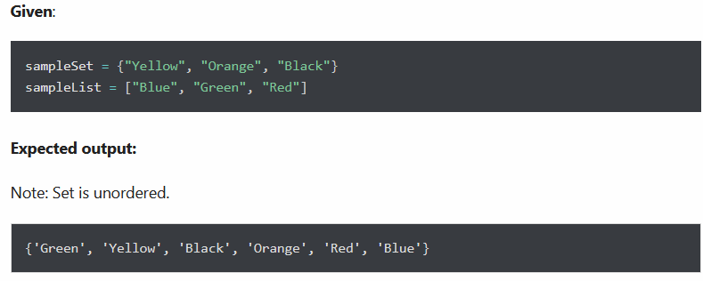

Exercise 2: Return a new set of identical items from a given two set

Exercise 3: Returns a new set with all items from both sets by removing duplicates

Exercise 4: Given two Python sets, update the first set with items that exist only in the first set and not in the second set.

Exercise 5: Remove items 10, 20, 30 from the following set at once

Exercise 6: Return a set of all elements in either A or B, but not both

Exercise 7: Check if two sets have any elements in common. If yes, display the common elements.

Exercise 8: Update set1 by adding items from set2, except common items

Exercise 9: Remove items from set1 that are not common to both set1 and set2

